SMART AGRICULTURE SYSTEM

---Team LoLLogic

Abstract:

This report documents a project developed to address problem statements focusing on the smart application of IoT hardware in the agricultural field. The project was undertaken as part of a hackathon, which outlined specific components to be utilized in devising solutions for the agricultural sector. The integration of IoT hardware in agriculture holds significant promise for optimizing resource management, enhancing crop yield, and improving overall efficiency in farming practices. This report presents the implementation details, working principle, and innovative features of the project, offering insights into the application of IoT technology to address agricultural challenges.

Working Principle:

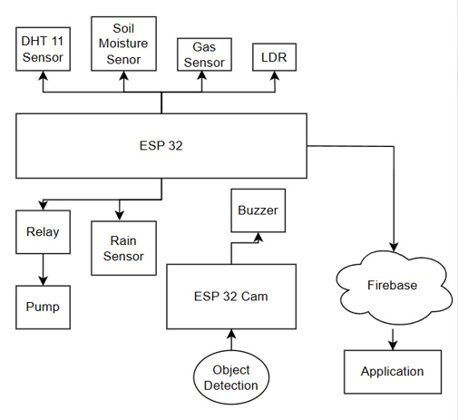

*1.1 System Architecture*

The project utilized a combination of multiple sensors, including DHT11, Rain Sensor, Soil Moisture Sensor, MQ-2 Gas Sensor, and LDR Sensor, to gather crucial data pertaining to the environmental conditions necessary for nurturing plant yield. The DHT11 sensor monitored temperature and humidity levels, while the Rain Sensor detected precipitation, enabling the system to adjust watering schedules accordingly. Soil Moisture Sensor measured soil moisture content, ensuring optimal hydration for the plants, while the MQ-2 Gas Sensor monitored gas levels to detect any potential hazards. Additionally, the LDR Sensor measured light intensity to ensure adequate exposure for photosynthesis.

The ESP32 microcontroller received data from all sensors and processed it to derive actionable insights. This data was then uploaded to a cloud database platform known as Firebase. Firebase provided a scalable and real-time database solution, facilitating seamless storage and retrieval of sensor data.

Furthermore, the cloud database was integrated with a website created for the project. The website served as a user interface, displaying real-time sensor data and historical trends. Additionally, the website incorporated a machine learning model based on the Rainforest Regression algorithm. This algorithm utilized the sensor data collected over time to predict optimal watering schedules for the plants. By analyzing the correlation between sensor inputs and plant health, the algorithm determined whether the pump should be activated to irrigate the crops, thereby optimizing resource usage and enhancing yield potential.

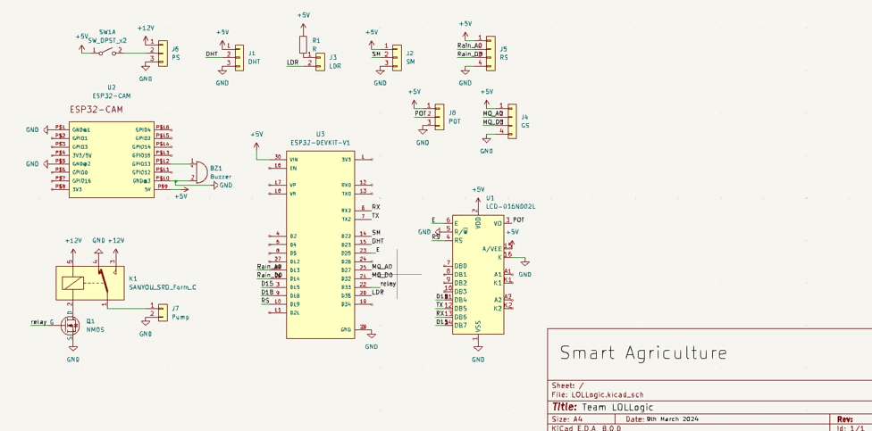

*1.2 Schematic Diagram*

Innovation:

In addition to the integration of multiple sensors and cloud-based data processing, the project implemented object detection using the ESP32 CAM module in conjunction with Edge Impulse software. This innovative approach enabled the system to measure the size of plants and estimate the amount of water required based on the type of crop being grown, in conjunction with the sensor data.

By leveraging object detection technology, the system could accurately identify the size and type of plants within the agricultural environment. This information, combined with the data collected from the various sensors, allowed for precise calculation of water requirements tailored to the specific needs of each crop.

Furthermore, this innovative feature significantly contributed to optimizing water usage by the irrigation system. For instance, if the detected crop was identified as a drought-resistant or "dry type" plant, the system could intelligently reduce the frequency or duration of watering cycles, thus minimizing the need for the pump to be activated unnecessarily. This adaptive approach to irrigation not only conserves water resources but also enhances the overall efficiency and sustainability of agricultural practices.

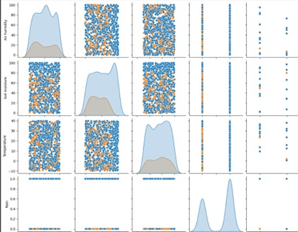

*1.3 Regression Graph*

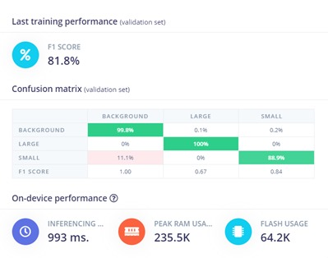

*1.4 Output for Edge Impulse*

Technical Stack:

Frontend:

1. HTML
2. CSS
3. Node.js
4. React.js
5. Charts.js

Backend/Cloud:

1. Firebase

ML Model:

1. Python (Google Colab)
2. Edge Impulse

Microcontroller:

1. C/C++

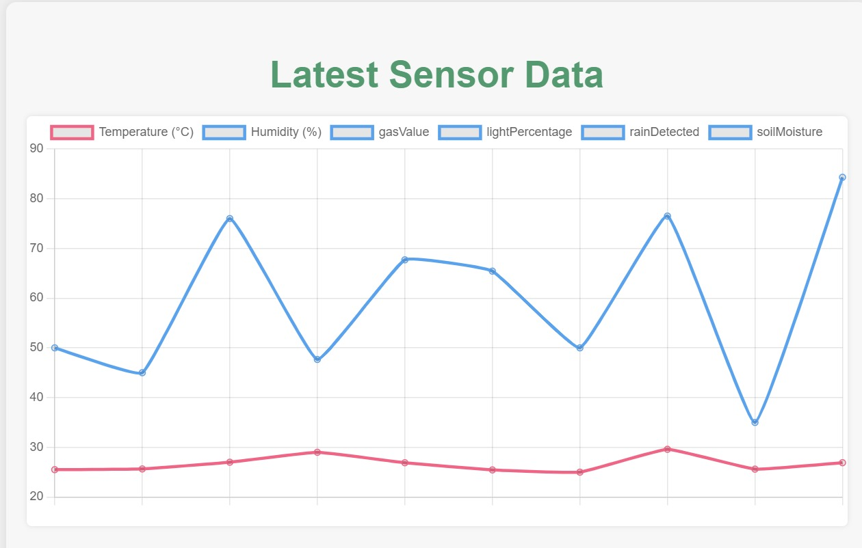

*1.5 Sensor Data Visualization*

Components Used:

- ESP32 Devkit V1

- ESP32 CAM Module

- 16x2 LCD Screen

- DHT11 Sensor

- Capacitive Soil Moisture Sensor

- MQ-2 Gas Sensor

- Rain Sensor

- LDR Sensor

- Relay Module

- USB to FTDI Encoder

- Lora SX1278

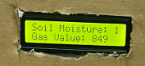

*1.6 Sensor Data on OLED Display*

Conclusion:

In conclusion, our project showcases the potential of IoT technology to revolutionize agriculture. By integrating sensors, cloud databases, and machine learning, we've created a system that optimizes crop management, conserves resources, and promotes sustainability. The innovative use of object detection for precise irrigation highlights the project's contribution to efficient farming practices. Moving forward, this project sets a precedent for the adoption of IoT in agriculture, offering scalable solutions to global food security challenges.

Link to Project:

<https://drive.google.com/drive/folders/1KP7JovmIbIzvODp4GKVxe7ycTQsnPU2y>